Translator Using GUI
END-TERM REPORT
BACHELOR OF TECHNOLOGY
in
COMPUTER SCIENCE AND ENGINEERING
By:
S.no. | Name | Roll No. | Registration no.
1. | K. Bavish Sai Reddy | 20 | 11902256
2. | G. Mallikarjun Reddy | 22 | 11902297
3. | Sk. Mohammad Reyaz | 29 | 11902242


Courses Code: INT213

School of Computer Science and Engineering
Lovely Professional University
Phagwara, Punjab (India)
Objective
The primary objective of this project is to implement what we’ve learnt throughout our course of Python programming and use that to develop a Graphical User Interface (GUI) for Translator with all the required functionalities. The translator makes possible exchange of information between the users of different languages by producing the translating language a text which has an identical communicative value with the text. This project also aims at providing a user friendly interface to the users to let them easily use the Translator. This application lets the user to translate a word or a sentence from any language to English and the pronunciation of the word can be known by the user. The main moto of the application is to help the user in translating the words to English and know the pronunciation of that word. This application also provides the user to store translated words for future reference. In this application we also provide to modes. Light mode for the users who likes light colors and Dark mode for the users who likes dark colors.
In this application we have created an attractive user interface. In this application we have a created an entry box and a output box. We have created a clear button. We have created a Translate button and a Speak button. We have created copy and save buttons. We have created a Exit button. We have created two modes like Light mode and Dark mode. We have created a Error box. We have created menu buttons like File, Edit, View etc… . We have created a Saved text box.
Introduction
In todays generation English is a language spoken by largest number of people across the globe after Chinese and Spanish. English language plays an important role in our lives because it makes possible communication between different countries as the only common language across the globe. It is the only language that truly connects the whole world or best way of communication for people all around the world,and Fluency in English is very important in your business,law or in your professional life. In today’s global world, the importance of English can not be denied and ignored since English is the most common language spoken everwhere.
Translation promotes global interaction thereby allowing interactive relationships in various fields such as technology, finance, trade etc. With the development of technology, it gas become very easy to reach across the nation just with the help of effective translation. Translation is also useful when companies need to tie up with local businesses, or make governmental proposals. Music, literature, films, and various other art forms transcend global boundaries because of the way they are effectively translated to reflect local languages and sentiments. No matter what you believe, the impact on history is undeniable. Translation is helping sports teams and organisations overcome language barriers and transcend international boundaries. TEDTalks’ OpenTranslation project makes the talks understandable to people around the world. There’s no denying the power of the English language.
GUI Screenshots and Explanation
1.Home Screen
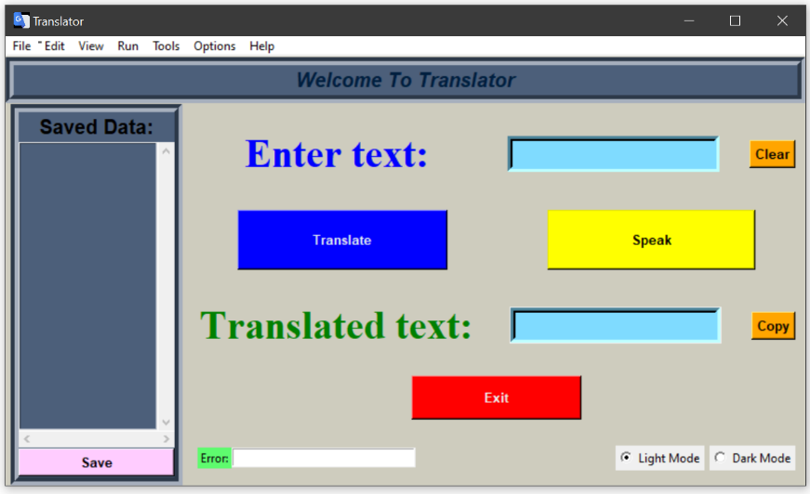
In the home screen we can see the entry box in which the user has to enter the word/sentence which he/she has to translate. The translate button translates the text entered by the user and displays the translated text in the output box. The Speak button makes the computer machine to speak out the translated text.
2.Translation
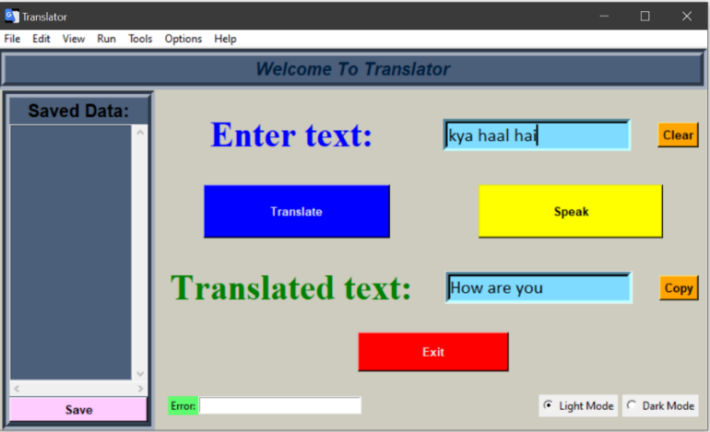
As above explained the user has entered the text and the text was translated and displayed in the output box.
3.Saving the data
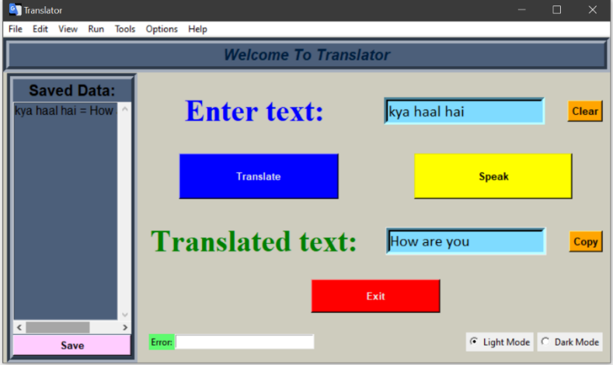
If the user wants to save the data then he/she wants to click on the copy button. The copy button copies the text entered by the user and the translated text. When the user clicks on the save button the copied text will be permanently saved in the database and the copied text will be displayed in the saved data box.
4.Modes
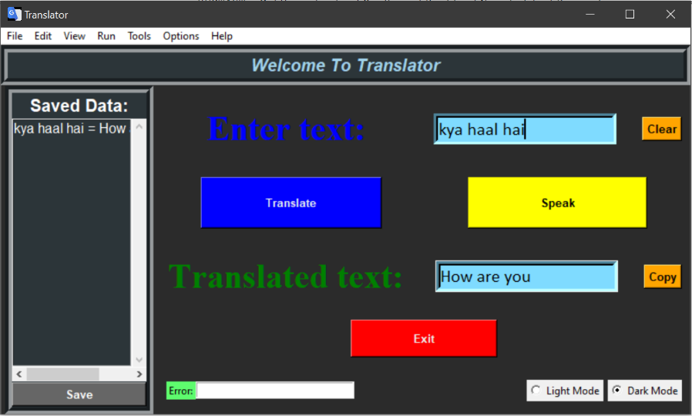
If the user likes dark colors we have provide two modes for the user. Light mode and Dark mode. When the user clicks on the dark mode the screen colors will be changed to dark colors and if the user wants light colors he/she can click on the light mode then the screen color will be changed to light colors.
5.Menu Buttons
5.1.File
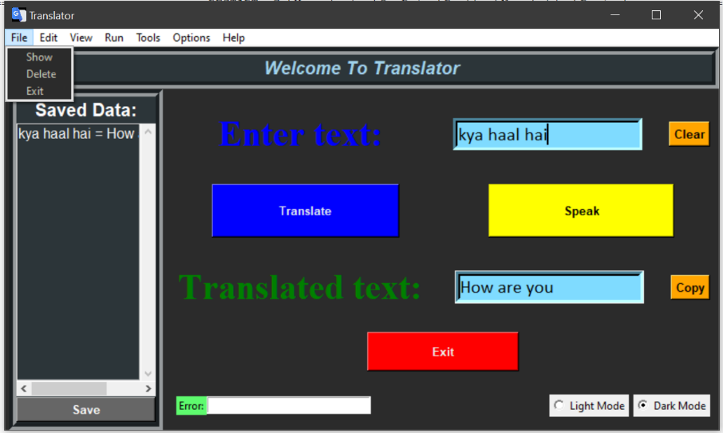
In the file menu there are three options Show, Delete, Exit. The show option displays the previously saved data in the saved data box. The Delete option deletes all the previously saved data permanently. The Exit button close the application.
5.2.Edit
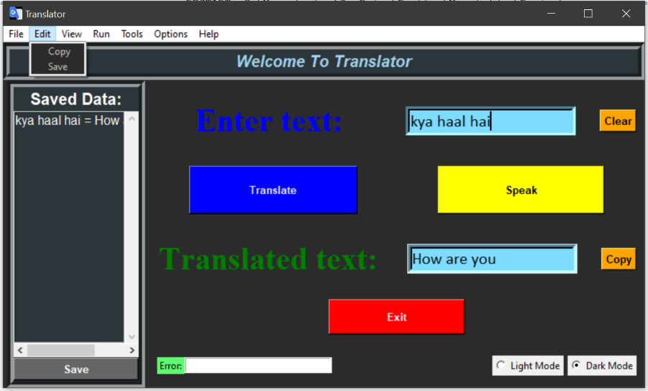
In the Edit menu there are two options Copy and Save. The copy option do copies the text entered by the user and the translated text. The save option saves the copied text and displays the copied text in the saved data box.
5.3View
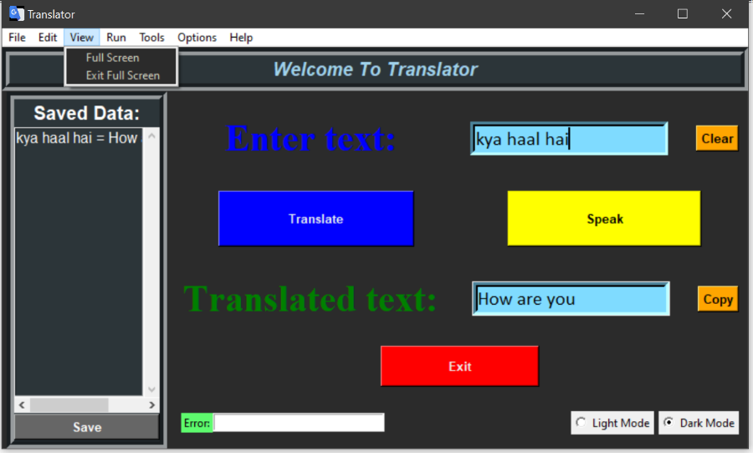
In the view button there are two options Full Screen and Exit Full Screen. The Full Screen option makes the applications window fit to the users screen. The Exit Full Screen option makes the applications window to normal state.
5.4.Run
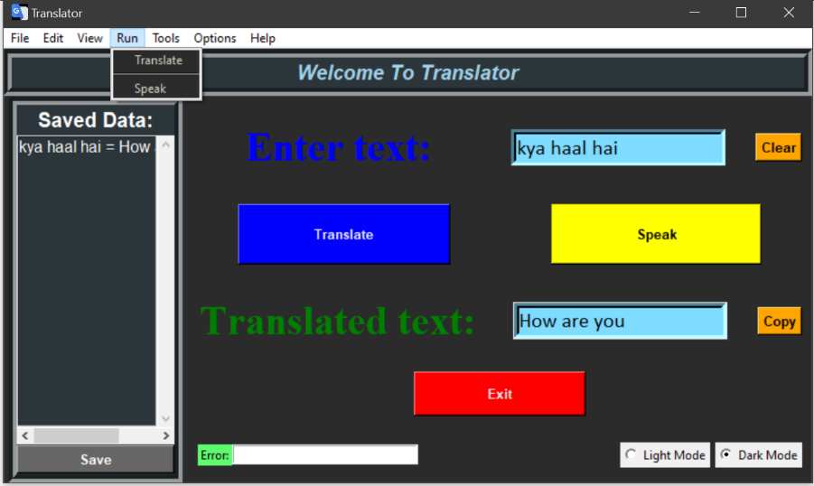
In the Run menu there are two options Translate and Speak. The Translate option translates the text entered by the user and displays the translated text in the output box. The Speak option makes the computer machine to speak out the translated text.
5.5.Tools
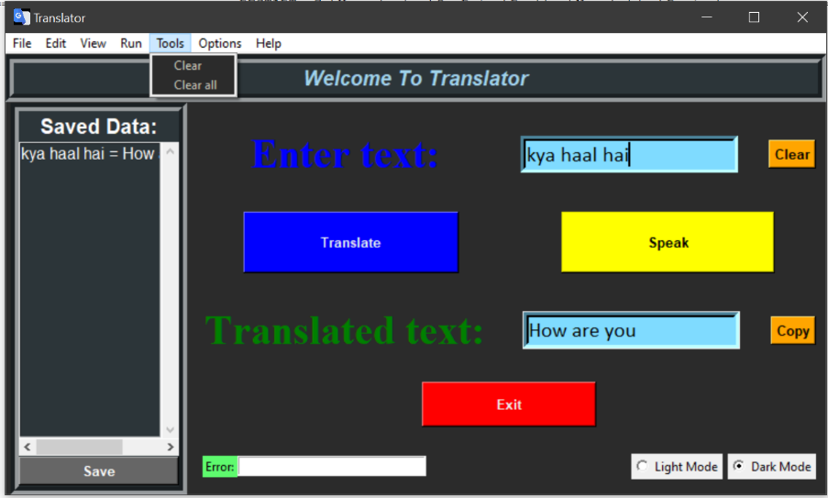
In the Tools menu there are two options clear and clear all. The clear option clears the text entered by the user in the entry box. The clear all options clears the all the contents on the screen.
5.6.Options
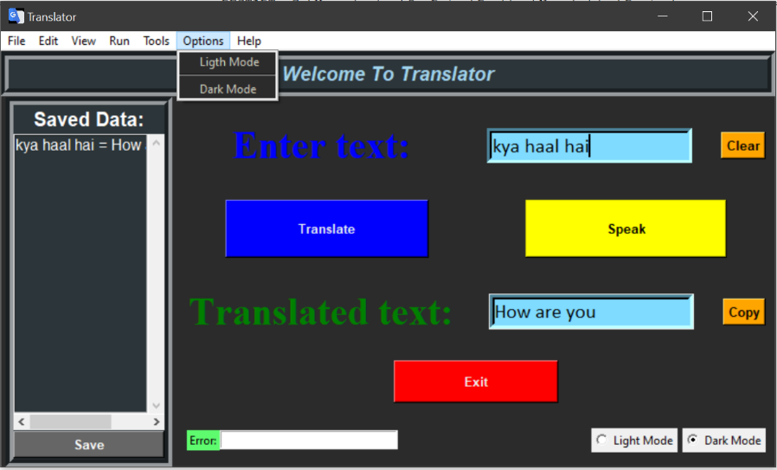
In the options menu there are two options Light mode and Dark mode. The Light mode changes the screen colors into light colors. The Dark mode changes the screen colors to dark colors.
5.7.Help
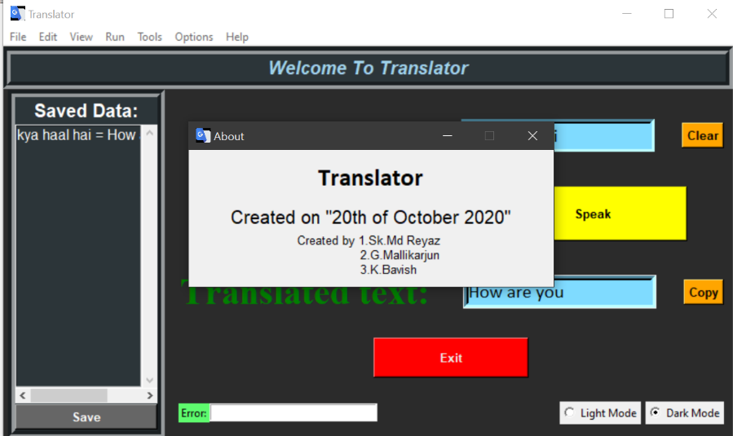
In the help menu there is one option About. When the user clicks on the About option a window will be pop up as shown in above picture.
6.Error Box
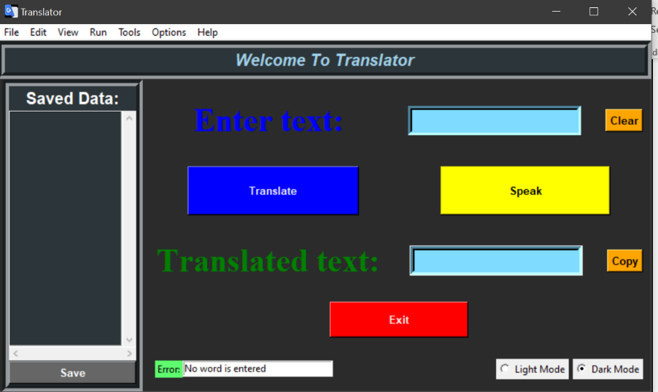
The error box displays the message when the user makes mistakes or tries to translate by not entering words/sentences etc… the error box displays the mistake that he is doing.
7.Exit Button
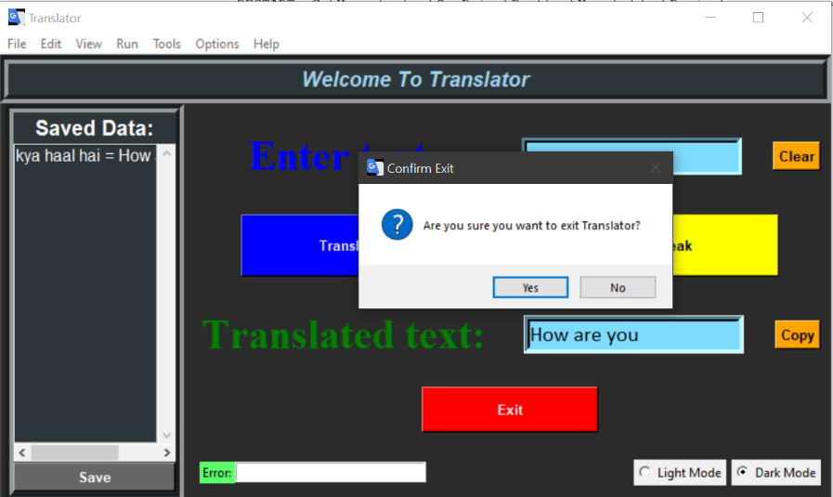
When the user clicks on the Exit button or clicks the Exit option in File menu or tries to close the window a message box will pop up to confirm the closing of the window.
Source Code
import mysql.connector
from googletrans import Translator
import pyttsx3
from tkinter import *
from tkinter import messagebox
root=Tk()
root.geometry("800x450")
root.title("Translator")
root.configure(bg="#CECCBE")
root.iconbitmap(r'2.ico')
en=StringVar()
i=IntVar()
mydb=mysql.connector.connect(host="localhost",user="root",passwd="*********",database="translator")
mycursor=mydb.cursor()
#mycursor.execute("create database Translator")
#mycursor.execute("create table Words (Enteredtext varchar(500),Translatedtext varchar(500))")
#mydb.commit()
def trans():
global word
word = en.get()
try:
if word == "":
e="No word is entered"
er.delete(0,"end")
er.insert("end",e)
else:
global speech
trans = Translator().translate(word)
speech = trans.text
txt.delete(0,"end")
txt.insert("end",speech)
er.delete(0,"end")
except:
e="Not connected to the internet"
er.delete(0,"end")
er.insert("end",e)
def speak():
try:
eng = pyttsx3.init()
sound = eng.getProperty("voices")
eng.setProperty("voice", sound[1].id)
eng.say(speech)
eng.runAndWait()
er.delete(0,"end")
except NameError:
e="No word is translated"
er.delete(0,"end")
er.insert("end",e)
def ext():
ans=messagebox.askquestion("Confirm Exit", "Are you sure you want to exit Translator?")
if ans == "yes":
root.destroy()
else:
return
def cllk():
root.config(bg="#CECCBE")
c1.config(bg="#CECCBE")
c2.config(bg="#CECCBE")
c3.config(bg="#CECCBE")
c4.config(bg="#CECCBE")
el.config(bg="#CECCBE")
tl.config(bg="#CECCBE")
f.config(bg="#4c5f7a")
cl.config(bg="#4c5f7a",fg="#000000")
c.config(bg="#4c5f7a")
text.config(bg="#4c5f7a",fg="#000000")
btp.config(bg="#FFCCFF",fg="#000000")
lf.config(bg="#4c5f7a",fg="#001f3f")
f1.config(bg="#CECCBE",fg="#000000")
f2.config(bg="#CECCBE",fg="#000000")
f3.config(bg="#CECCBE",fg="#000000")
f4.config(bg="#CECCBE",fg="#000000")
f5.config(bg="#CECCBE",fg="#000000")
f6.config(bg="#CECCBE", fg="#000000")
f7.config(bg="#CECCBE", fg="#000000")
def cldk():
root.config(bg="#2B2B2B")
c1.config(bg="#2B2B2B")
c2.config(bg="#2B2B2B")
c3.config(bg="#2B2B2B")
c4.config(bg="#2B2B2B")
el.config(bg="#2B2B2B")
tl.config(bg="#2B2B2B")
f.config(bg="#2C3539")
cl.config(bg="#2C3539",fg="white")
c.config(bg="#2C3539")
text.config(bg="#2C3539",fg="#ffffff")
btp.config(bg="#666666",fg="#FFFFFF")
lf.config(bg="#2C3539",fg="#a0d2eb")
f1.config(bg="#2B2B2B",fg="#CECCBE")
f2.config(bg="#2B2B2B",fg="#CECCBE")
f3.config(bg="#2B2B2B",fg="#CECCBE")
f4.config(bg="#2B2B2B",fg="#CECCBE")
f5.config(bg="#2B2B2B",fg="#CECCBE")
f6.config(bg="#2B2B2B",fg="#CECCBE")
f7.config(bg="#2B2B2B",fg="#CECCBE")
def clk():
r2.config(value=0)
r1.config(value=1)
def cdk():
r2.config(value=1)
r1.config(value=0)
def clr():
ety.delete(0,"end")
def cla():
ans=messagebox.askquestion("Confirm Clear", "It clears the 'Saved Data' \n But don't worry the Data is stored")
if ans=="yes":
ety.delete(0,"end")
txt.delete(0,"end")
text.delete(0,"end")
else:
return
def cpy():
global cp,x,y
try:
word=en.get()
if word=="":
e="No word is entered"
er.delete(0,"end")
er.insert("end",e)
else:
x=word
y=speech
cp=x+" = "+y+"\n"
return cp
except NameError:
e="No word is entered/translated"
er.delete(0,"end")
er.insert("end",e)
def pst():
try:
text.insert("end",cp)
form = "insert into words (Enteredtext,Translatedtext) values(%s,%s)"
mems = [(x, y)]
mycursor.executemany(form, mems)
mydb.commit()
except NameError:
e="No word is copied"
er.delete(0,"end")
er.insert("end",e)
def dlt():
ans=messagebox.askquestion("Warning","Permenantly deletes all the Stored Data",default="no",icon="warning")
if ans=="yes":
text.delete(0,"end")
mysql = "TRUNCATE TABLE Words"
mycursor.execute(mysql)
mydb.commit()
else:
return
def shw():
text.delete(0, "end")
mycursor.execute("select * from words")
myres = mycursor.fetchall()
i=1
for r in myres:
row=str(i)+'.'+r[0]+'='+r[1]
text.insert("end",row)
i=i+1
def abt():
win=Toplevel()
win.title("About")
win.geometry("400x150")
win.resizable(False, False)
win.iconbitmap(r'2.ico')
w=Label(win,text="Translator",font=("Calibri",20,"bold"),width=10)
w.pack(pady=10)
c=Label(win,text='Created on "20th of October 2020"',font=("Arial",15))
c.pack()
b=Label(win,text=("Created by 1.Sk.Md Reyaz \n \t 2.G.Mallikarjun \n 3.K.Bavish"),font=("Arial",10))
b.pack()
def clf():
root.attributes("-fullscreen",True)
def cle():
root.attributes("-fullscreen",False)
mb=Menu(root)
root.config(menu=mb)
f1=Menu(mb,tearoff=False,bg="#CECCBE",fg="#000000")
mb.add_cascade(label="File",menu=f1)
f1.add_command(label="Show",command=shw)
f1.add_command(label="Delete",command=dlt)
f1.add_command(label="Exit",command=ext)
f2=Menu(mb,tearoff=False,bg="#CECCBE",fg="#000000")
mb.add_cascade(label="Edit",menu=f2)
f2.add_command(label="Copy",command=cpy)
f2.add_command(label="Save",command=pst)
f3=Menu(mb,tearoff=False,bg="#CECCBE",fg="#000000")
mb.add_cascade(label="View",menu=f3)
f3.add_command(label="Full Screen",command=clf)
f3.add_command(label="Exit Full Screen",command=cle)
f4=Menu(mb,tearoff=False,bg="#CECCBE",fg="#000000")
mb.add_cascade(label="Run",menu=f4)
f4.add_command(label="Translate",command=trans)
f4.add_separator()
f4.add_command(label="Speak",command=speak)
f5=Menu(mb,tearoff=False,bg="#CECCBE",fg="#000000")
mb.add_cascade(label="Tools",menu=f5)
f5.add_command(label="Clear",command=clr)
f5.add_command(label="Clear all",command=cla)
f6=Menu(mb,tearoff=False,bg="#CECCBE",fg="#000000")
mb.add_cascade(label="Options",menu=f6)
f6.add_command(label="Ligth Mode",command=lambda : [cllk(),clk()])
f6.add_separator()
f6.add_command(label="Dark Mode",command=lambda : [cldk(),cdk()])
f7=Menu(mb,tearoff=False,bg="#CECCBE",fg="#000000")
mb.add_cascade(label="Help",menu=f7)
f7.add_command(label="About",command=abt)
f=Frame(root,bg="#4c5f7a",borderwidth=8,relief=GROOVE)
f.pack(side=TOP,fill=X,pady=1)
lf=Label(f,text="Welcome To Translator",bg="#4c5f7a",fg="#001f3f",font="Arial 15 italic bold")
lf.pack()
c=Frame(root,bg="#4c5f7a",borderwidth=8,relief=GROOVE)
c.pack(side=LEFT,fill=Y,padx=5)
btp=Button(c,text="Save",font="Arial 10 bold",bg="#FFCCFF",command=pst)
btp.pack(side=BOTTOM,fill=X,pady=1)
cl=Label(c,text="Saved Data:",fg="black",bg="#4c5f7a",font=("Arial",15,"bold"))
cl.pack()
sx=Scrollbar(c,orient=HORIZONTAL)
sx.pack(side=BOTTOM,fill=X)
sy=Scrollbar(c)
sy.pack(side=RIGHT,fill=Y)
text=Listbox(c,font="Arial 12",fg="#000000",bg="#4c5f7a",width=15,height=30,xscrollcommand=sx.set,yscrollcommand=sy.set)
text.pack()
sx.config(command=text.xview)
sy.config(command=text.yview)
c1=Frame(root,bg="#CECCBE",height=200,width=250)
c1.pack(fill=X)
c2=Frame(root,bg="#CECCBE",height=200,width=250)
c2.pack(fill=X,pady=1)
c3=Frame(root,bg="#CECCBE",height=200,width=250)
c3.pack(fill=X)
el=Label(c1,text="Enter text:",font=("Times new roman",30,"bold"),fg="blue",bg="#CECCBE",height=2,width=12)
el.pack(side=LEFT,pady=2,padx=2)
btc=Button(c1,text="Clear",font="Arial 10 bold",bg="orange",command=clr)
btc.pack(side=RIGHT,padx=10)
ety=Entry(c1,textvariable=en,width=20,font=("Calibri",15),bg="#7FDBFF",borderwidth=5)
ety.pack(side=RIGHT,padx=20)
tb=Button(c2,text="Translate",font=("Arial",10,"bold"),fg="#e2ebf0",bg="blue",command=trans,height=3,width=25,activebackground="#6699FF")
tb.pack(side=LEFT,pady=5,padx=50)
sb=Button(c2,text="Speak",font=("Arial",10,"bold"),fg="#000000",bg="yellow",command=speak,height=3,width=25,activebackground="#FFFF99")
sb.pack(side=RIGHT,padx=50)
tl=Label(c3,text="Translated text:",font=("Times new roman",30,"bold"),fg="green",bg="#CECCBE",height=2,width=12)
tl.pack(side=LEFT,pady=2,padx=2)
btc=Button(c3,text="Copy",font="Arial 10 bold",bg="orange",command=cpy)
btc.pack(side=RIGHT,padx=10)
txt=Listbox(c3,height=1,width=20,font=("Calibri",15),bg="#7FDBFF",borderwidth=5)
txt.pack(side=RIGHT,padx=20)
bte=Button(root,text="Exit",font=("Arial",10,"bold"),bg="red",fg="#EEEEEE",command=ext,height=2,width=20)
bte.pack()
c4=Frame(root,height=100,bg="#CECCBE")
c4.pack(side=BOTTOM,fill=X,pady=15,padx=10)
r1=Radiobutton(c4,text="Dark Mode",value=1,variable=i,command=cldk)
r1.pack(side=RIGHT)
r2=Radiobutton(c4,text="Light Mode",value=0,variable=i,command=cllk)
r2.pack(side=RIGHT,padx=5)
erl=Label(c4,text="Error:",bg="#5EFB6E")
erl.pack(side=LEFT)
er=Listbox(c4,height=1,width=30)
er.pack(side=LEFT)
root.protocol("WM_DELETE_WINDOW",ext)
root.mainloop()

Results
We finally created a “Translator” which translates the text from any language to English.
To create this application we used the following modules:
- googletrans
- tkinter
- mysql.connector
We leant how to create an GUI application using tkinter in python and we also learnt how connect the data base with python using mysql.
In this application the end user can translate the words from any language to English. The user can also know the pronunciation of the translated word/sentence. The user can also save the text for future references. The user can keep the appearance of the application as he likes. The user can also access the entire application from the menu buttons. The user can know the mistakes he/she is doing by the interactive error message.

Github link: https://github.com/Reyaz27/Translator
References

- https://www.w3schools.com/python/
- https://www.geeksforgeeks.org/sql-using-python/
- https://stackoverflow.com/
- www.tutorialspoint.com
- www.reddit.com
- www.google.co.in
- www.quora.com
- https://www.python-course.eu/index.php
- http://www.dealingdata.net/2016/08/21/Python-MySQL-GUI/
- www.blog.pythonlibrary.org
- http://effbot.org/tkinterbook/

